

Practical No. : 5
Aim –
Use JavaScript function types, scope, closures; apply try-catch; build a palindrome checker.
Software/Tools Required –
VSCode, Chrome, HTML5, CSS3, Javascript (ES6)
Experiment Program Code –
Index.html
<!DOCTYPE html>
<html lang="en">

<head>
<meta charset="UTF-8">
<meta name="viewport" content="width=device-width, initial-scale=1.0">
<title>Shopping Cart Calculator</title>

<style>
body {
font-family: Arial;
background: #f2f2f2;
margin: 0;
padding: 0;
}

.container {
width: 800px;
margin: 30px auto;
background: white;
padding: 20px;
border-radius: 10px;
box-shadow: 0 0 10px gray;
}

h2 {
text-align: center;
}

input {
padding: 8px;
width: 150px;
margin: 5px;
}

button {
padding: 10px;
cursor: pointer;
}

table {
width: 100%;
border-collapse: collapse;
margin-top: 20px;
}

table, th, td {
border: 1px solid black;
}

th {
background: #007bff;
color: white;
}

th, td {
padding: 10px;
text-align: center;
}

.result {
margin-top: 20px;
font-size: 18px;
}

footer {
margin-top: 30px;
padding: 15px;
text-align: center;
background: #007bff;
color: white;
border-radius: 5px;
font-size: 15px;
}
</style>
</head>

<body>

<div class="container">

<h2>Shopping Cart Calculator</h2>

<input type="text" id="name" placeholder="Product Name">

<input type="number" id="price" placeholder="Price">

<input type="number" id="qty" placeholder="Quantity">

<button onclick="addProduct()">Add Product</button>

<table id="cartTable">
<tr>
<th>ID</th>
<th>Product</th>
<th>Price</th>
<th>Quantity</th>
<th>Total</th>
</tr>
</table>

<div class="result" id="result">

<h3>Item Summary</h3>
<ul id="summary"></ul>

<h3>Expensive Products (Price > 1000)</h3>
<ul id="expensive"></ul>

</div>

<footer>
Developed by Sanskruti Gorle | PRN - 24070521025
</footer>

</div>

<script>

let cart = [];

function addProduct() {

let name = document.getElementById("name").value;

let price = parseFloat(
document.getElementById("price").value
);

let qty = parseInt(
document.getElementById("qty").value
);

if (name == "" || isNaN(price) || isNaN(qty)) {

alert("Please enter all fields");

return;
}

let product = {

id: cart.length + 1,

name: name,

price: price,

quantity: qty
};

cart.push(product);

displayCart();

document.getElementById("name").value = "";

document.getElementById("price").value = "";

document.getElementById("qty").value = "";
}

function displayCart() {

let table = document.getElementById("cartTable");

table.innerHTML = `
<tr>
<th>ID</th>
<th>Product</th>
<th>Price</th>
<th>Quantity</th>
<th>Total</th>
</tr>
`;

cart.forEach(function(item) {

table.innerHTML += `
<tr>
<td>${item.id}</td>
<td>${item.name}</td>
<td>${item.price}</td>
<td>${item.quantity}</td>
<td>${item.price * item.quantity}</td>
</tr>
`;

});

let total = cart.reduce(function(sum, item) {

return sum + (item.price * item.quantity);

}, 0);

let discount = 0;

if (total >= 50000) {

discount = total * 0.20;

}

else if (total >= 20000) {

discount = total * 0.10;

}

else if (total >= 5000) {

discount = total * 0.05;

}

let finalAmount = total - discount;

document.getElementById("result").innerHTML = `

<b>Total Amount :</b> ${total}<br>

<b>Discount :</b> ${discount.toFixed(2)}<br>

<b>Final Amount :</b> ${finalAmount.toFixed(2)}

<h3>Item Summary</h3>

<ul id="summary"></ul>

<h3>Expensive Products (Price > 1000)</h3>

<ul id="expensive"></ul>

`;

let summary = document.getElementById("summary");

summary.innerHTML = "";

cart.map(function(item) {

summary.innerHTML +=
`<li>${item.name} : ${item.price * item.quantity}</li>`;

});

let expensive = document.getElementById("expensive");

expensive.innerHTML = "";

let exp = cart.filter(function(item) {

return item.price > 1000;

});

exp.forEach(function(item) {

expensive.innerHTML +=
`<li>${item.name}</li>`;

});

}

</script>

</body>

</html>

Output –
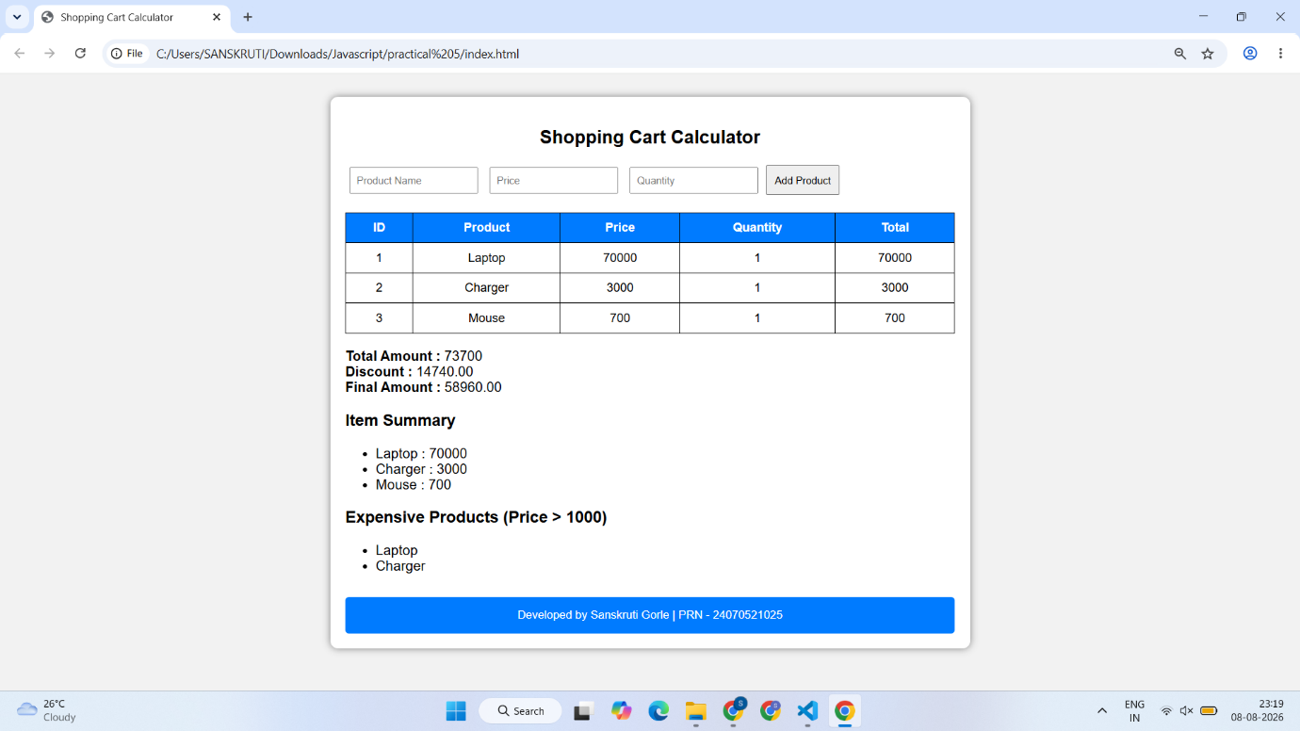
Case Study Title –
To study the functioning of Arrays and Loops in Java Script
a) Create and manipulate arrays: push, pop, shift, unshifit, splice, slice. b) Use array methods: mapO, filter(), reduce(), forEach (.
Case Study: -
Create an array of numbers and find the maximum and minimum value.
Case Study Program Code –
index.html
<!DOCTYPE html>
<html lang="en">
<head>
<meta charset="UTF-8">
<meta name="viewport" content="width=device-width, initial-scale=1.0">
<title>Maximum & Minimum Finder</title>

<link rel="stylesheet" href="style.css">

<link href="https://fonts.googleapis.com/css2?family=Poppins:wght@300;400;500;600;700&display=swap" rel="stylesheet">
</head>
<body>

<div class="container">

<div class="icon">🧮</div>

<h1>Maximum & Minimum Finder</h1>

<p class="subtitle">
Enter array elements separated by commas
</p>

<label>Array Elements</label>

<input
type="text"
id="numbers"
placeholder="Example : 12,45,89,6,34">

<button onclick="findValues()">
Analyze Array
</button>

<div id="result"></div>

</div>

<script src="script.js"></script>

<footer class="footer">
Designed &amp; Developed by
<strong>Sanskruti Gorle</strong><br>
<span>PRN: 24070521025</span>
</footer>
</body>
</html>

style.css
*{
margin:0;
padding:0;
box-sizing:border-box;
font-family:'Poppins',sans-serif;
}

body{

min-height:100vh;

display:flex;
flex-direction:column;
justify-content:center;
align-items:center;

background:#F7F3EE;

background-image:
radial-gradient(circle at top left,#F3E5D7 0%,transparent 35%),
radial-gradient(circle at bottom right,#E8DCCF 0%,transparent 35%);

padding:20px;
}

.container{

width:410px;

background:#FFFDFC;

padding:28px;

border-radius:22px;

border:1px solid #EFE6DD;

box-shadow:0 15px 35px rgba(95,72,52,.12);

}

.icon{

width:65px;
height:65px;

margin:auto;

display:flex;
justify-content:center;
align-items:center;

border-radius:50%;

font-size:30px;

background:#E8D8C7;

color:#6B4F3B;

margin-bottom:15px;
}

h1{

text-align:center;

color:#4B3621;

font-size:24px;

margin-bottom:5px;

font-weight:700;
}

.subtitle{

text-align:center;

color:#8B735D;

margin-bottom:20px;

font-size:14px;
}

label{

display:block;

color:#5F4B3A;

font-weight:500;

margin-bottom:8px;
}

input{

width:100%;

padding:12px;

border:2px solid #E6D7C8;

border-radius:14px;

outline:none;

background:white;

font-size:15px;

transition:.3s;
}

input::placeholder{

color:#B39B87;
}

input:focus{

border-color:#A47551;

box-shadow:0 0 0 4px rgba(164,117,81,.12);
}

button{

width:100%;

margin-top:16px;

padding:12px;

border:none;

border-radius:14px;

background:#8B5E3C;

color:white;

font-size:15px;

font-weight:600;

cursor:pointer;

transition:.3s;
}

button:hover{

background:#6F4A2F;

transform:translateY(-2px);

box-shadow:0 10px 18px rgba(111,74,47,.20);
}

button:active{

transform:scale(.98);
}

#result{

display:none;

margin-top:18px;

background:#FCFAF8;

border:1px solid #EFE3D8;

border-radius:16px;

padding:15px;

animation:fade .4s ease;
}

.result-title{

font-size:17px;

font-weight:600;

color:#4B3621;

margin-bottom:12px;
}

.row{

display:flex;

justify-content:space-between;

align-items:center;

padding:10px 12px;

margin:8px 0;

background:#F8F4EF;

border-radius:10px;
}

.label{

color:#6F5B4A;

font-weight:500;
}

.value{

font-weight:600;

color:#4B3621;

text-align:right;

word-break:break-word;
}

.max{

color:#2E7D32;
}

.min{

color:#C0392B;
}

.footer{

margin-top:18px;

padding-top:14px;

border-top:1px solid #EFE3D8;

text-align:center;

font-size:12px;

color:#8B735D;

line-height:20px;
}

.footer strong{

color:#5F4B3A;

font-weight:600;
}

.footer span{

color:#A08A76;

font-size:12px;
}

@keyframes fade{

from{

opacity:0;
transform:translateY(12px);

}

to{

opacity:1;
transform:translateY(0);

}

}

script.js
function findValues(){

let input = document.getElementById("numbers").value.trim();

if(input==""){

alert("Please enter array elements.");
return;

}

let arr = input.split(",").map(Number);

let max = arr[0];
let min = arr[0];

arr.forEach(function(number){

if(number > max){
max = number;
}

if(number < min){
min = number;
}

});

let result = document.getElementById("result");

result.style.display = "block";

result.innerHTML = `

<div class="result-title">
📋 Analysis Result
</div>

<div class="row">
<span class="label">Array</span>
<span class="value">${arr.join(", ")}</span>
</div>

<div class="row">
<span class="label">Maximum Value</span>
<span class="value max">🟢 ${max}</span>
</div>

<div class="row">
<span class="label">Minimum Value</span>
<span class="value min">🔴 ${min}</span>
</div>

`;

}

Output –
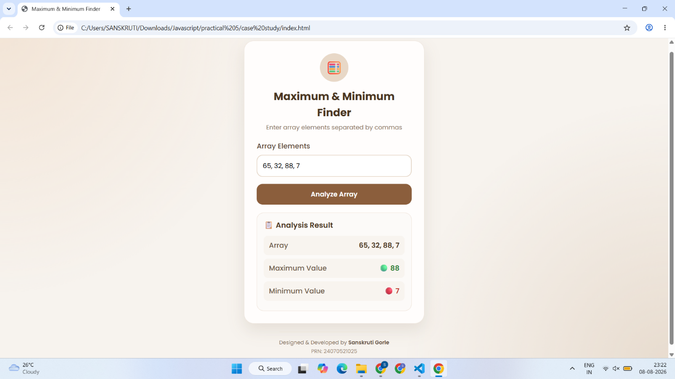

Conclusion –
The experiment was successfully performed to study JavaScript arrays, array manipulation methods, array iteration methods, loops and object handling. A Shopping Cart Calculator was developed to store product objects, calculate the total amount and apply discount logic. A Maximum and Minimum Finder was also implemented using array traversal to determine the largest and smallest values from an array of numbers.

